**Potential Modifications to LANDFIRE BpS models for the USGS Current Condition Modeling Project**

Draft: 30 October 2019

Blue Mtns. Ecoregion Montane Sage Steppe

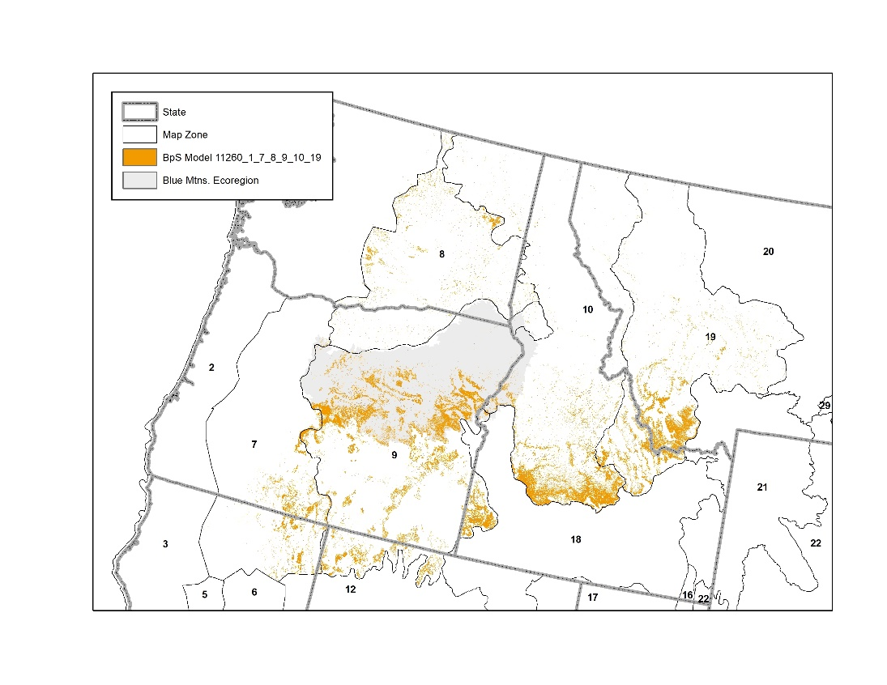*This is a current condition model based on the LANDFIRE 11260_1_7_8_9_10_19 BpS model and description and modified based on several sources to represent current conditions. The primary source was an unpublished model by Miles Hemstrom created for the Blue Mtns. and representing Mountain Big Sagebrush – With Juniper. A similar model was created and documented in Creutzburg et al. 2012. The initial conditions are based on LANDFIRE 2014 sclass geospatial data for the Blue Mtns. Ecoregion.*

**States**

1. What additional states are needed, and why?
   1. New states are needed to represent invasion of juniper into sagebrush and the presence of invasive annual grasses with and without tress. New states are: Juniper: Invaded, Juniper:Exotic, and Grass:Exotic.
   2. *Key Question: is a Sage/Shrub:Exotic state needed? The Hemstrom and Creutzburg et al. models include this state. For simplicity, the current model uses Grass:Exotic to cover exotic grasslands with and without shrubs.*
2. What states should be modified, and how?
   1. The state names for native states were changed to be more intuitive

|  |  |
| --- | --- |
| **LANDFIRE Name** | **New Name** |
| Early 1 All | Grass:Native |
| Mid 1 Open | Sage:Savanna |
| Late 1 Open | Sage:Steppe |
| Late 1 Closed | Sage:Shrubland |

1. What states should be deleted, and why?
   1. none

**Deterministic Transitions**

1. Do any existing succession pathways need to be modified?
   1. no
2. Are there new succession pathways for additional or modified states?
   1. Each new state succeeds to itself
   2. No transitions to new states will be deterministic

**Probabilistic Transitions**

1. What additional disturbances are needed, and why?
   1. What is the rate and pathway for the new disturbance in each state?
      1. Add new disturbance types to project, assigned each to its own and the AllTransitions group: Encroachment, Grazing, GrazeDegrade, and Recovery
         1. **Encroachment** represents Juniper encroachment into the late seral native shrubland
            1. Added to encroachment from Sage:Shrubland to Juniper:Invaded with probability based on the NativeRecoveryJuniper transition in the Hemstrom model
            2. Crutzeberg states “juniper establishment events (where applicable) occurred from late-successional shrub steppe into phase I woodlands (Evers 2010)” (p. 78)
         2. **Grazing** represents the impact of moderate livestock grazing and does not cause a state change
            1. Added grazing to all states with a probability identical to the moderate grazing probability from the Hemstrom model
2. *Key question:* *How much grazing is taking place and how should it be attributed in the model?* *Grazing and GrazeDegrade (below) are key disturbances in this system, and the amount and impact of it should be carefully considered and locally calibrated. The current model uses probabilities. If this approach is taken in the future, grazing and GrazeDegrade could be attributed with single probability, and proportion could be used to account for the amount of the landscape subject to moderate vs. degrading grazing. Alternatively temporal multipliers or area targets could be used. Evers et al. (2013) and Ford et al. (2019) discuss different methods for attributing grazing.*
   * + 1. **GrazeDegrade** represents the combined effects of heavy livestock grazing within two years post-fire disturbance which causes a transition to an exotic state
          1. Added GrazeDegrade with a TST Max of 2 years to all states except exotic states based on Crutzeberg and Hemstrom model.
          2. To ensure that GrazeDegrade could occur only with in two years of fire or drought I added a transition group to the project called Fire-or-Drought and assigned replacement fire, mixed fire, surface fire, and wind/weather/stress (i.e. drought) transition types to the group. In the Scenario, under Advanced|Time Since Transition|Time Since Transition Group I assigned GrazeDegrade to the Fire-or-Drought group.
          3. Crutzeberg explains the use of TST: “transition can only occur within 2 years following a fire or drought” (p.78)
          4. Heavy grazing can also occur without other disturbances, but the probability for this transition is low (.005) in the Hemstrom model. For simplicity and because I didn’t think it would have a major impact in a 20 year run, I did not include this transition.
       2. **Recovery** represents natural recovery of native vegetation from exotic vegetation based on rationale from Creutzburg
          1. Added recovery from Juniper:Exotic to Juniper:Invaded and from Grass:Exotic to Sage:Savanna
          2. Model probabilities and TST Min settings based on Hemstrom model settings for native recovery from degraded states
          3. Modeled the transition from Grass:Exotic to Sage:Savanna based on Evers. I experimented with using proportion to allow recovery into all native states, but this did not substantially change the results.
          4. Crutzburg states: “in cool-moist sites, recovery from exotic grass states was modeled to occur automatically unless it was heavily grazed reflecting the higher competitive ability of native bunchgrasses in mesic sites” (p.78)
          5. *Key Question: the Hemstrom model includes recovery from Degraded not Exotic States. Evers models a deterministic transition from Cheatgrass to Mid Seral Open (roughly equivalent to Sage:Savanna). Is recovery from Exotic to Native possible?*
     1. Attribute new transitions to and from the added states
        1. Added drought (using Wind or Weather or Stress) to the Juniper:Invaded, Juniper:Exotic, and Exotic:Grass states at same rate as in native states
        2. Added mixed and replacement fire to Juniper:Invaded based on Hemstrom model
        3. Added replacement and mixed fire with a probabilities of .0089 to Juniper:Exotic based on Cruetzberg model (p.79)
        4. Added replacement fire with a probability of .0089 to Grass:Exotic based on Cruetzberg model (p.79)
     2. Added management actions as Transition Types to the project based on LANDFIRE disturbance classes. Types added are: Mechanical Remove, Mechanical Add, Fire, Chemical, and Biological. These transitions are not used the model but could be added and attributed to explore management actions.
3. How should existing disturbance rates and pathways be modified?
   1. Added mixed fire in native sage states based on Hemstrom model
   2. Updated replacement fire probabilities in all native states based on Hemstrom model
4. Should any existing disturbances/pathways be deleted, and why?
   1. No. Assumed that Option 1 (freezekill), Option 2 (voles), Insects/Disease, and Wind or Weather or Stress disturbances have not changed.

**Initial Conditions**

|  |  |
| --- | --- |
| **State** | **Initial Conditions** |
| Grass:Native | 25 |
| Sage:Savanna | 0 |
| Sage:Steppe | 60 |
| Sage:Shrubland | 2 |
| Grass:Exotic | 6 |
| Juniper:Invaded | 3.5 |
| Juniper:Exotic | 3.5 |

1. What do we use for initial conditions?
   1. Current conditions calculated from LANDFIRE 2014 sclass for the Blue Mtns. Ecoregion. The LANDFIRE sclass UN class cross-walks to the Juniper states in this model. I split the amount of UN into the Juniper:Invaded and Juniper:Exotic states because LANDFIRE data doesn’t distinguish the understory.
   2. Remember to add new states to the initial conditions even if they start with nothing in them

**Run Control**

1. How many cells should be used, and what is their size?
   1. 209,224 cells, representing ~10 acres each. There are 2,092,238 acres of this BpS today in the Blue Mtns. Ecoregion as estimated from LANDFIRE 2014 sclass data (included only naturally vegetated areas, excluded Ag, Barren, Developed). I decreased simulation time by making each cell represent ~10 acres.
2. How many years should we run the simulations?
   1. 20 year planning timeframe
3. How many simulations should we run?
   1. 40 (Leonardo’s recommendation)
4. Other settings?
   1. Set the Time Since Transition | Time Since Transition Group on Advanced tab
      1. GrazeDegrade transition type assigned to Fire-or-Drought Transition Group
      2. Recovery transition type assigned to GrazeDegrade Transition Group
   2. Set Time Since Transition Randomize | Initial TST Max on Advanced tab
      1. Initial TST Max for GrazeDegrade is 10; set based on the LANDFIRE standard: initial TST Max is set to the maximum Min TST used in the model
      2. Initial TST Max for Fire-or-Drought set to 74 years. This setting was estimated by considering the possible range of time since fire or drought on the landscape. Initial model results showed a probability for fire of .0066 and for drought (wind or weather or stress) of .0069. The cumulative probability of drought and fire is .0135 or about 74 years. In other words, drought or fire will occur about every 74 years and therefore, TST values were assumed to range from 0-74.

**Output Options**

1. Annual
2. Periodic, and what periods?
   1. State class every 1, include 0
   2. Transitions every 1

**Results**

1. LANDFIRE original model

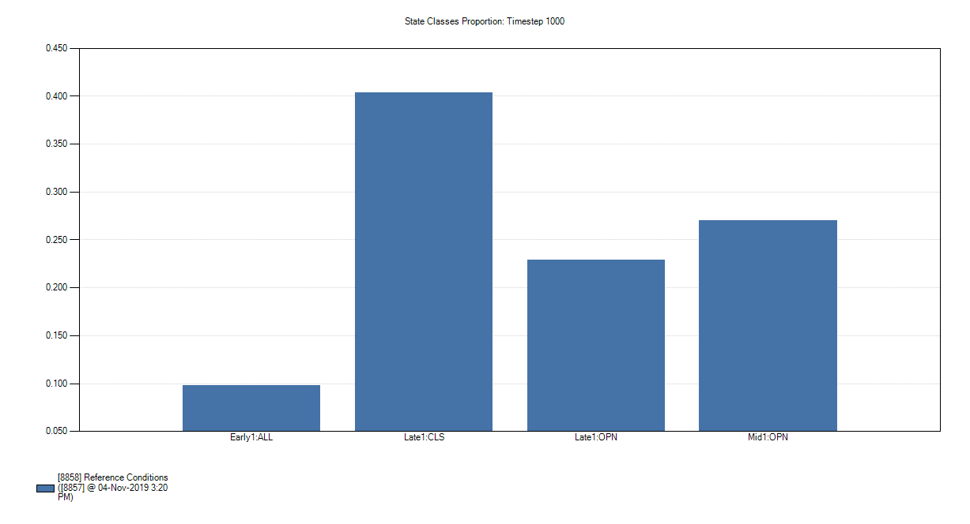

1. Current condition model
   1. Creutzburg’s 2000-2050 projections for SE OR show juniper woodland expansion affecting more than half the cool-moist type and exotic invasion affecting about 1/3

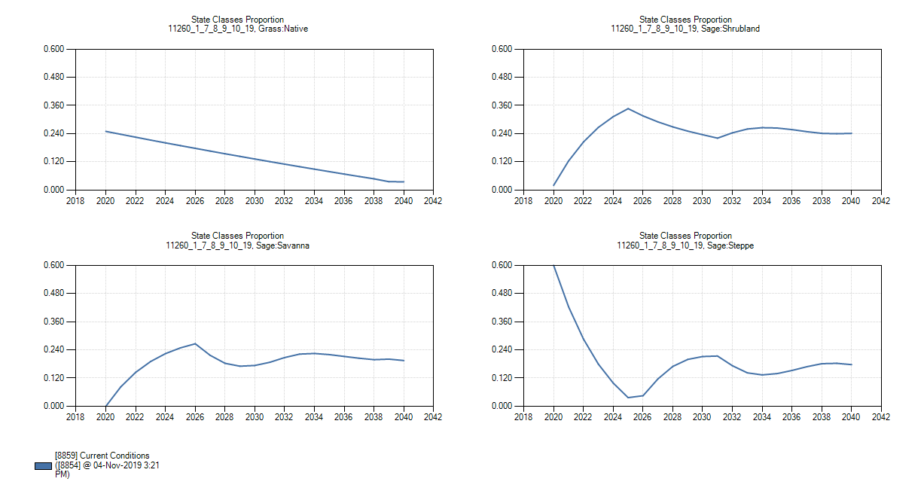

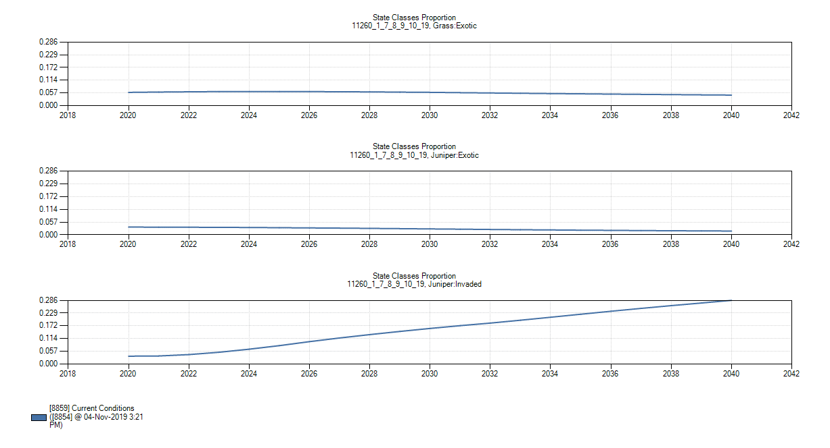

1. LANDFIRE vs. Current condition model mean fire return interval (MFRI)

|  |  |  |
| --- | --- | --- |
| **Severity** | **LANDFIRE-MFRI** | **CURRENT-MFRI** |
| Replacement | 29 | 303 |
| Moderate (Mixed) |  | 384 |
| Low (Surface) |  |  |
| All Fires | 29 | 169 |

**Citations**

Creutzburg, M.K.; Halofsky, J.S.; Hemstrom, M.A. 2012. Using state-and-transition models to project cheatgrass and juniper invasion in southeastern Oregon sagebrush steppe. In: Kerns, B.K.; Shlisky, A.J.; Daniel, C.J., tech. eds. Proceedings of the First Landscape State-and-Transition Simulation Modeling Conference, June 14–16, 2011, Portland, Oregon. Gen. Tech. Rep. PNWGTR-869. Portland, OR: U.S. Department of Agriculture, Forest Service, Pacific Northwest Research Station: 73–84. Available: <https://www.fs.fed.us/pnw/pubs/pnw_gtr869.pdf>

Evers, L., et al. 2010. Modeling sage-grouse habitat using a state-and-transition model. Corvallis, OR: Oregon State University. Ph.D. dissertation. 180 p.

* References to Evers in this document refer to what Evers calls the cool-moist sagebrush group

Ford, P.L., M.C. Reeves, and L. Frid. 2019. A tool for projecting rangeland vegetation response to management and climate. Rangelands. 41(1): 49-60. <https://doi.org/10.1016/j.rala.2018.10.010>

Hemstrom, Miles model was created for the Blue Mtns. and represents Mountain Big Sagebrush – With Juniper (OBM_smb)